Include Graphic, sounds, HTML, mail merge, style,font type .

Progrmming:

Programming is the process of creating a set of instructions that tell a computer how to perform a task. Programming can be done using a variety of computer programming languages, such as JavaScript, Python, and C++.



**Programming Definition (Audio)**

Programming Language:

Computers understand instructions that are written in a specific syntactical form called a programming language. A programming language provides a way for a programmer to express a task so that it could be understood and executed by a computer.



List of Top Programming Language:

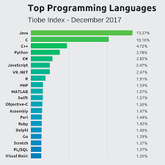

Adding HTML:

**Web Layout** is uesd to view in HTML form. Web Layout is designed to show you what your document would like if you intend to publish it as a webpage.

Mail Merge:

**Mail Merge** is a handy feature that incorporates data from both **Microsoft Word** and **Microsoft** Excel and allows you to create multiple documents at once, such as letters, saving you the time and effort of retyping the same letter over and over.

Example: I have connected this ms sheet to one of excel sheet now I will use “insert merge field” to merge both

«Student_Name» «Home_Work_1» «Home_Work_2» «Home_Work_3» «Total_Marks» «Grading»

I can use “preview results” to see the values imside columns of these labels

We can change rows by selecting row number from the box nest to “preview result” box